The Alumni Association of the University of Massachusetts Boston, Inc.
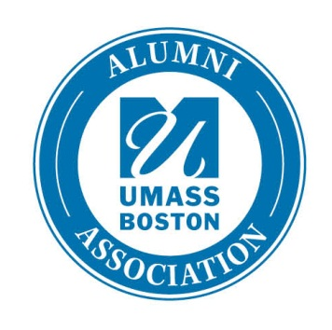
2013 Scholarship Application Form

Multiple awards of $4,000 or more to be awarded for the spring 2013 semester. Awards are renewable each academic year.

Qualifications:
- Undergraduate student
- Strong academic record (marked improvement over time is considered)
- Demonstrated financial need
- Demonstrated commitment to the University of Massachusetts Boston through campus involvement, leadership, etc., will be considered.

To apply, send:

- A completed application by March 1, 2013
Applications are available in the Merit Scholarship Office, Campus Center, 4th
floor and in the Office of Alumni Relations, Quinn Building, 2nd floor.

- A personal statement of 500-1000 words about why you chose to attend UMass Boston and what the university means to you.

- A current transcript (unofficial is acceptable).

- One letter of recommendation from a UMass Boston faculty member.

Additional Information:
This scholarship is funded by the Alumni Association of the University of Massachusetts Boston. The recipients and final award amounts are determined by the Alumni Association Board of Directors Scholarship Committee. Recipients will receive the scholarship in Spring 2013 and will be presented with an official scholarship certificate at the Alumni Board of Directors meeting in June 2013 at the UMass Club in Boston. Recipients must attend to be eligible for renewal in the 2013-2014 academic year. The Alumni Association of the University of Massachusetts Boston, Inc. is an independent, non-profit organization formed to support UMass Boston’s students and the University’s mission.

Alumni Association Scholarship
Application Form

Name____________________________________Student ID #______________________Gender (optional) □ M □F
Email_________________________________________________ Telephone _____________________________
Mailing Address_________________________________________________________________________________
Hometown ______________________________________ High School ____________________________________
UMB Major(s)_____________________________ Minor__________________ Intended Field___________________
Completed credits at UMass Boston __________ _ Credits enrolled __________ Cumulative GPA ___________

Do you have a FAFSA on file with UMass Boston for the 2012-2013 year? □ Yes □ No
Are you receiving student financial aid through UMass Boston for the 2012-13 year? □ Yes □ No
Total amount of aid you are receiving that does not have to be repaid (grants etc.) $__________
Total amount of aid you are receiving that does have to be repaid (loans) $__________
Total amount of scholarship money you are receiving (scholarships, prizes, awards) $__________
Is your parent an alumnus? If so what is their name and year of graduation? □ Yes □ No
______________________________________________________________________________________________
Activities, Hobbies, Memberships (Use a separate sheet if necessary).
___________ ___________ ______________________
___________ ___________ ______________________
___________ ___________ ______________________

Employment Experience and Dates: (Use a separate sheet if necessary).
___________ ___________ ______________________
___________ ___________ ______________________
___________ ___________ ______________________

Written Release
I certify that all the information on this application is true. My signature further signifies my permission to release all information
contained in my scholarship application packet, as well as relevant information on record at the University of Massachusetts Boston, to any
and all persons involved in the selection of scholarships, for the sole purpose of consideration for scholarship awards.
I further consent to the release of such information for reporting purposes to the donor of any scholarships I may receive. The Committee agrees that all disclosures provided by the student and the Enrollment Services Office will be kept confidential.
Signature:_______________________________________________________________ Date:____________________________
Return this form along with your personal statement, transcripts and letters of recommendation to:
University of Massachusetts Boston
Alumni Association Scholarship Committee
c/o Merit Scholarship Office
Campus Center, Room 4100

Deadline for application is March 1, 2013

